**Worksheet 5 – Decision Making**

1. Mention 1 advantage of IF statement over switch statement.

___________________________________________________________________________

1. Mention 1 advantage of switch statement over IF statement.

___________________________________________________________________________

1. Evaluate the following expressions containing relational operators

|  |  |
| --- | --- |
| **Expression** | **True / False** |
| 5 == 5 |  |
| 5 != 5 |  |
| 5 != 4 |  |
| 5 < 7 |  |
| 5 <= 5 |  |
| 1. > 9 |  |

1. Evaluate the following expressions containing logical operators

|  |  |
| --- | --- |
| **Expression** | **True / False** |
| true && true |  |
| false && true |  |
| true || false |  |
| false || true |  |
| ! true |  |
| ! false |  |

1. Write a program to ask the user what the time is, in 24 hour clock (hour only). So the user should enter a number between 1 and 24. The program should output the following, depending on the user input.

|  |  |
| --- | --- |
| **Range** | **Output** |
| 1 - 11 | “Morning” |
| 12 | “Noon” |
| 13 – 16 | “Afternoon” |
| 17 - 23 | “Evening” |
| 24 | “Midnight” |

1. Write a program that accepts two numbers and write a conditional expression that prints “the value of variable 1 is greater”, “the value of variable 2 is greater”, or “they are equal”.
2. Write a program which reads the user’s age. Afterwards, the program should produce an output as specified in the flowchart below.

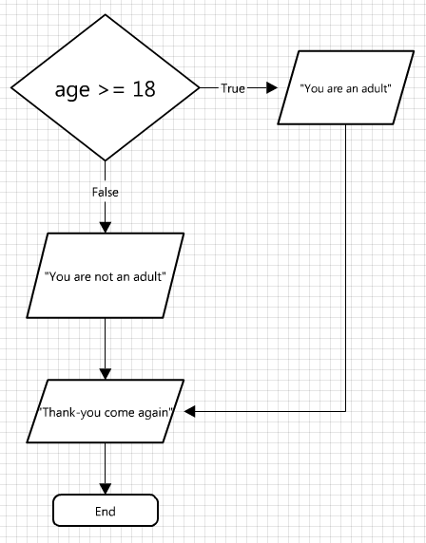

1. Write a program which asks the user for a number between 1 and 7. Afterwards the program should output the day (Monday-Sunday) corresponding with the given number. Use a **switch** statement. Also, the switch statement should output “Invalid number” in case the user enters a number not in the expected range.
2. Write a program which asks the user for a price (double). Also, the user should be asked whether he would like tax to be applied (char – Y or N). If no, the program should output the price as it is. Otherwise the program should add 18% to the original price and output the updated price.
3. Write a program which asks the user for a number (1-100) and outputs whether it is odd or even.
4. Write a program which asks the user for a number (1-10). The program also generates a number between 1 and 10 (at random). The program should then output whether the user guessed the number or not.

The following example shows you how to generate a random number **0-9**:

Random r = new Random();

int randNum = r.NextInt(10); //random number 0-9

Similar to the Scanner class, you need to import the Random class, as follows:

import java.util.Random;

**Challenging Questions!**

1. Write a program which asks the user to input his username and password. Afterwards the program should display “Logged in” if his username was “*Admin*” or “*administrator*” and his password was “*123*”. Else, “Invalid Credentials” is output.

Hint: Strings should never be compared using == as with numbers. Instead use the following method:

boolean theSame = str1.equals(str2);

1. Write a program which generates a colour (RED, GREEN, YELLOW or BLUE) at random and outputs the result. Hint: generate a random number first!
2. Write a program, which, given the size of the 3 sides of a triangle, decides whether the triangle is equilateral (3 equal sides), isosceles (2 equal sides) or scalene (no equal sides). NOTE: this is a difficult question, and nested IF statements are required!